Basic ACO Pheromone Update

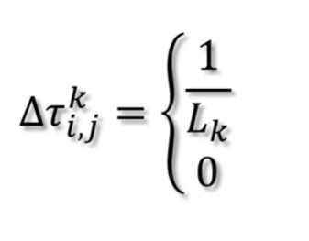

Delta Tau – the amount of pheromone that an ant can deposit

Subscript i and j shows the edge connecting nodes i and j

K is representative of a single agent (kth ant)  
  
  
The first part of this equation shows the pheromone amount deposited by the Kth ant on the edge connecting node i and j – this equates to 0 if the ant does not traverse an edge at all

Lk – the length of the path found by the Kth ant – we divide this by 1 as we are trying to find the shortest path, the shorter the path the higher the pheromone to be deposited by the ant

Calculating pheromone amount on each edge (no evaporation)

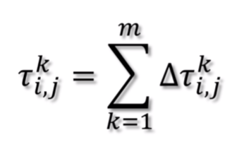

Summation of K is equal of 1^m where m is equal to the total number of ants.

Evaporation

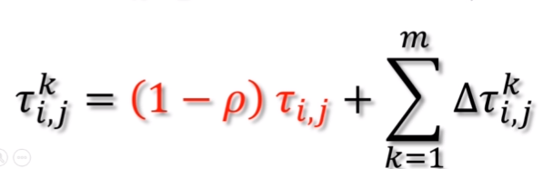  
  
If we want to simulate evaporation we must add an additional section to the equation.

This states that the pheromone deposit is equivalent to 1 minus row times the current pheromone level plus the new pheromone that should be deposited by all ants. Row is a constant that defines the evaporation rate.

The next step is to use the pheromones calculated in the first step to select a path.

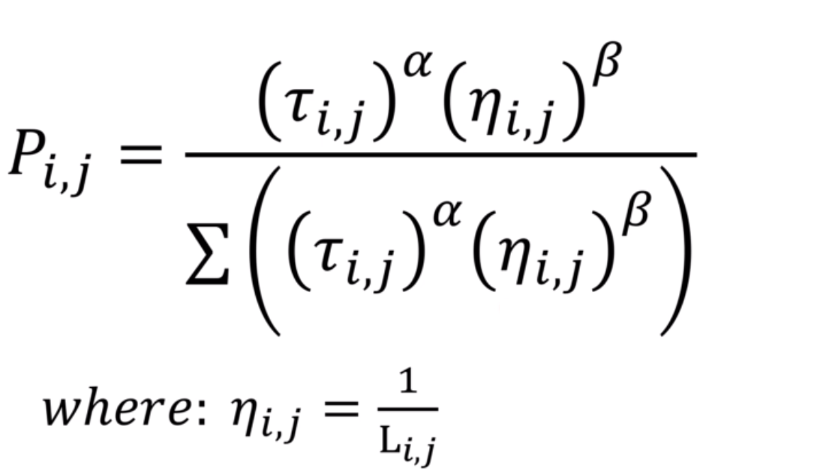

In this equation we simulate the path selection based on how ants use determine a chosen path via probabilistic values.

P is the probability

i and j is the edge between two nodes

Eta indicates the quality of the edge

Using Alpha and Beta we can increase the impact of Tau or Eta in the decision making process

The denominator of the equation is the pheromone and quality of all edges which can be considered from the node i this probability is calculated for all edges connected to the current number and is represented as a number between 0 and 1

Note that if you want a decision based just on the pheromone level Eta can be removed from the equation denominator

Where: the length of an edge (or cost) indicates the quality of the edge

Alpha and Beta are often assumed to be 1 unless the impacts are to be changed

Once we have calculated the probabilities of selecting the paths we still need to be able to select these paths based on the probabilities. We do this using a technique called Roulette Wheel.

We first calculate the cumulative sum by adding the current probability to itself and each of the other probabilities to the right.

After this calculation we no longer use the probability vectors, we replace these with the cumulative sum and use this number to select the path.

This is done by generating a random number between 0 and 1 we then select the path based on which two numbers this random number is generated between